Ryan Mendoza
Period 5
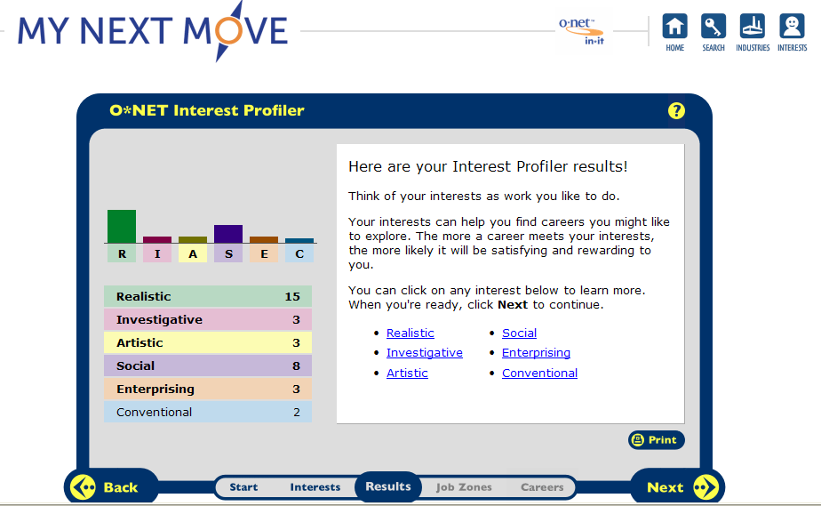

My top two are realistic and social. This is very accurate because the skills include: figuring out problems, talking to people, and being able to understand people. These skills fit me very well, and one of the jobs that includes these skills is a probation officer which is what I’ve always wanted to be. Another job that interests me that is social is physical education professor.
The top personality types linked to the specific careers are:
Ten careers that match my two personality types are:
- Law, Public safety, corrections & security (correctional officer)
- Manufacturing
- Transportation, Distribution, & Logistics
- Architecture and Construction
- Landscaping
- Coaching
- Sport recreation and fitness
- Child and adult care

Correctional Officer
- Responsible for overseeing individuals who have been arrested and are awaiting trial or who have been convicted of a crime and sentenced time in jail, reformatory, or penitentiary.

- Some of the related occupational fields are police officers, detectives, probation officers, and correctional treatment specialists.

- The “realistic” personality trait best suits the career of Law.

- The kind of education that is required is a high school diploma, and some agencies require some sort of college experience. Every employee must go through a training academy. Also military experience is seen as a plus for the job. The age limit is 18 years old without any felony convictions. Also correctional officers must be in good health

- Technology skills needed would be: PC computers, word processing, the internet, and email

- The average earnings for a correctional officer can earn anywhere between $12.52 to $32.33 per hour and between $26,000 and $67,000 per year depending on education and rank. In the Massachusetts area average yearly earnings are between $25,790 - $31,710.

- The projected growth within the next 10 years is +9% so there will be approximately 42,900 more jobs for correctional officers in 10 years.

- The organizations that would hire a correctional officer is any prison who is in need of the job.

- The jobs working conditions can be stressful and hazardous. Correctional officers have one of the highest nonfatal injuries on the job.

- Yes this job is usually part of a union.

- Advancement in this job is a promotion to Correctional Sergeant. Correctional sergeants supervise correctional officers and are usually responsible for maintaining security in the areas needed. Also Correctional Sergeants make at least $10,000 more in salary than correctional officers or jailors.

Motor vehicle and parts Manufacturing

- Motor vehicle and parts manufactoring includes the making of automobiles and the parts that go in them.
- Related occupational fields are industries that manufacture; steel, rubber, plastics, glass, and other basic materials.
- The personality type that this career best suits is the realistic type.
- Education that is required for this career is college ecperience, trade schools, or technical institutes. Also industries will pay tuition for any employee who enrolls in colleges, and technical institutes.
- Technology skills that are needed to be successful in this job are basic mathamatics, computer programming, and electronics.
- This careers earnings are averaged between $668 and $1,251 per week depending on your specific job and over time. Yearly this job offers between $34,000 and $65,000 depending on your specific job. In this area of the country is somewhat low. It is more towards the southeast and midwest, the best place In the country to be for this career is Detriot, Michigan.
- The job projection is likely to grow 7% in the next ten years.
- Some oganizations that would hire a car manufacturer would be; Ford, Chevy, Mercedes, etc.
- The working environment of this career is considered uncomfortable by being hot, fumes, and loud noise. The working schedule is averaged at 8 hours a day and 40 hours per week, also over time is very common especially during peak demands.
- No this is not a union job.

- The opportunities for advancement in this career are through more educatin. With more education you can become and engineer. The only promotion is to supervisor and that is after years of experience in the field.
Transportation, Distribution, and Logistics
- Plan, direct, or coordinate storage, distribution activities in accordance with organizational policies and applicable government laws or regulations.
- Some related occupational fields would be management
- Personality type best suited for this job is the realistic type
- The kind of education needed for this job would be a masters degree in Business administration and management
- Technology skills needed for this job would be: Cadre Technologies Cadence Transportation Management System, IBM i2 Transportation Manager, Freight Rail Crew Optimization Scheduling FRCOS software, and IMSure Solutions SHIPflex.
- This occupation’s earnings can be between $62,000 and $120,000 each year depending on location of job
- The projected growth of this job is not likely to grow within the next ten years
- Companies that would hire a transportation manager would be: NFI Logistics, Gold Medal, and Openmile.
- Working conditions are mainly in offices. In the building it can be hot, and noisy
- Transportion managers are not part of the union.
- The only advancement in management is to own a company

Architecture
- An Architects job is to plan and design structures, such as private residences, office buildings, theaters, factories, and other structural property.
- Some related occupational fields are: engineering, mechanical drafters, construction.
- The personality type that is best suited for this job is the realistic type.
- To be an architect you need the minimum of 5 years for a bachelors degree in an architecture degree program. Then you must work in the field for training until ready to be a licensed architect.
- Technology skills needed to be an architect is CAAD programming.
- Architects annual earnings can range between $40,000 and $138,000 depending on their experience. In the massachusetts are the average earnings for an architect is about $85,000
- Projected growth for architecture in the next ten years is supposed to grow about 16%
- Organizations for architecture are: The American Architectural Foundation, American Society of Landscape Architects, and The Applied Technology Council.
- Working conditions for architecture is usually comfortable since they are consulting with their clients in their offices most of the time.
- Yes architecture is part of the union.
- Advancement for architects can be awarded by getting a cetificate from The National Council of Architectural Registration Boards. This certificate makes it easier to be licensed across the states.

Landscaping
- Landscaping workers maintain grounds of property using hand or power tools or equipment.
- Some of the related occupational fields are engineering, and maintenance.
- The Personality type for this job is the realistic type.
- Landscaping workers need a high school diploma to pursue their career. Training needed is with the machines used on the job.
- Technology skills needed for the job are only with the tools used in the jobs. Such as weed trimmers, lawn mowers, etc.
- A landscaping worker can make between $16,000 and $37,000 depending on experience and company pay. In the Massachusetts area workers make around $30,000.
- New job opportunities are expected to grow within the next ten years.
- A company that would hire a landscaping worker would be All Seasons Landscaping which is located in Somerset, Massachusetts.
- The working conditions for this job can be very hot in the summer, very cold in the winter. Normal hours are 40 per week, but overtime is very common on this job.
- No this job is not part of the union
- Opportunities for advancement in this career is to become a landscaping supervisor which can happen with experience on the job.

Coaching
- Coaches organize amateur and professional athletes and teach them the fundamental skills of individual and team sports.
- Related occupational fields are: physical training, physical education teaching, etc.
- The personality type is social
- Education needed for this career is the experience of the specific sport for at least two years, also knowledge of the sport is required.
- Technology skills are not needed for this occupation
- The highest paid 10 percent is $15,000 and the highest paid 10 percent is $62,000. Areas more towards the south pay a little more than the north because football is bigger in the south in college.
- Projected growth is supposed to rise 5% in this occupation within the next ten years.
- Organizations that would hire a coach are; Pop Warner leagues, high schools, middle schools, and colleges.
- The working environment includes 40 hours per week for several months during the season. Also it is held outside for most of the time so all weather conditions come into play.
- Yes this is a union job.
- Opportunities for advancement would be from secondary school levels to college levels and into professional leagues.

Sport recreation and fitness

- Personal trainers help clients assess their level of physical fitness and set and reach fitness goals. Also demonstrate various exercises and help clients improve their exercise techniques.

- Related occupational fields are occupations such as fitness directors, group exercise instructors, and fitness workers.

- The best personality type for this career is the social type.

